SYSTEM DESIGN

Group name

First Airbenders

Project name

COMFORT HOME

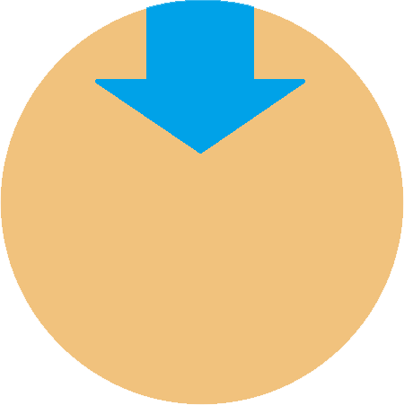

|  |  |  |  |
| --- | --- | --- | --- |
| Name | Student number | Email | Role |
| Stefan Teeuwen | 3654900 | 415849@student.fontys.nl | Scrum Master/Project Leader |
| Viktor Ivanov | 3774147 | 425404@student.fontys.nl | Engineer |
| Ahmad Alzarkaoui | 3741834 | 441396@student.fontys.nl | Engineer |
| Ivaylo Ivanov | 3853764 | 432022@student.fontys.nl | Engineer |

Table of Contents

Hardware 3

Wiring diagram 3

System design 4

System context diagram 4

System architecture diagram 4

Communication protocols 4

Control flow diagram 5

State diagrams 6

Embedded board states 6

C# state 6

# Hardware

The indoor climate control system consists of several components which interact with each other. The hardware required is as follows:

1. STM32 Nucleo-64 development board with STM32F303RE MCU.
2. ETRX357 Zigbee module.
3. CM1106 CO2 sensor.
4. SHT20 temperature and humidity sensor.
5. IAQ-Core VOC sensor.
6. Optional extensions, i.e. a fan, multiple CO2 sensors or other humidity and temperature sensors.

# Wiring diagram

# System design

## System context diagram

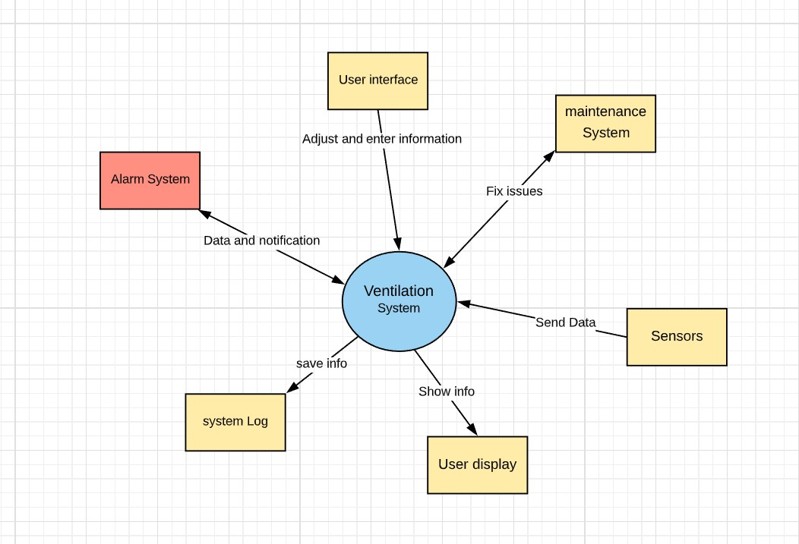

## System architecture diagram

[ missing – please update ]

# Communication protocols

The embedded board has a couple of sensors connected to it. Each one of them has to communicate with the board through a given communication protocol. They are as follows:

1. The temperature and humidity sensor uses I²C.
2. The VOC sensor uses I²C.
3. The CO2 sensor uses UART.

Communication between the Embedded board and the C# application will be based on a custom protocol which will be agreed on with 3 other

teams in the future. Communication will occur once every 15 minutes or at sudden changes of sensor readings.

# Control flow diagram



# State diagrams

## Embedded board states



## C# state

